Homework 1 Malware Analysis
James Stallkamp
CS 373
James Stallkamp
For homework 1 I mostly used process monitor, process explorer and fakeNet to investigate the sample in this homework. I executed the sample and used process monitor to find the operations that the malware was performing. I found that that the Evil.eve file was modifying a large number of .dll files in the System23 folder and even hijacked a command prompt and windows service host. Eventually the malware created a folder “C:\ntldrs\ and would occasionally create files there.
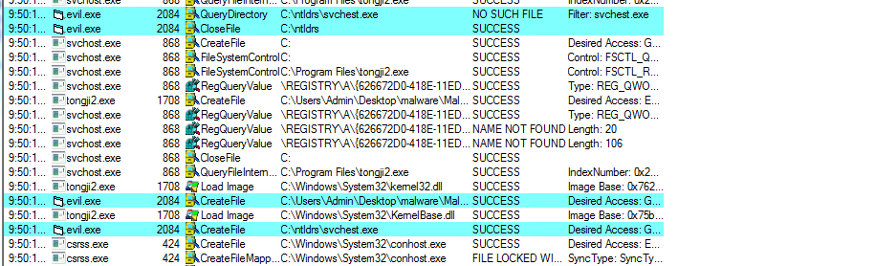
Initially it created a svchest.exe file that was hijacked from windows to do many different tasks. This sample also added a task to the window start up to start this svchest.exe so that the malware would be executed whenever the machine was started.
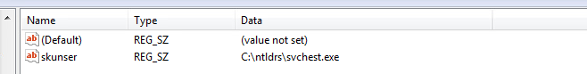
Using the AT command, I found that the svchest.exe file was being scheduled to run every 30 minutes on the hour. I decided to investigate what exactly was happening every thirty minutes and I found that the svchest was not only protecting itself and the evil.exe file but also running this tongji2.exe file.
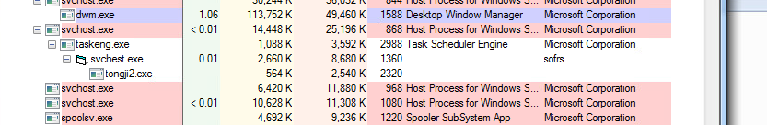
I then used process explorer to dump strings from this tongji.exe and found that it was getting a large amount of system information and attempting to send out this information.
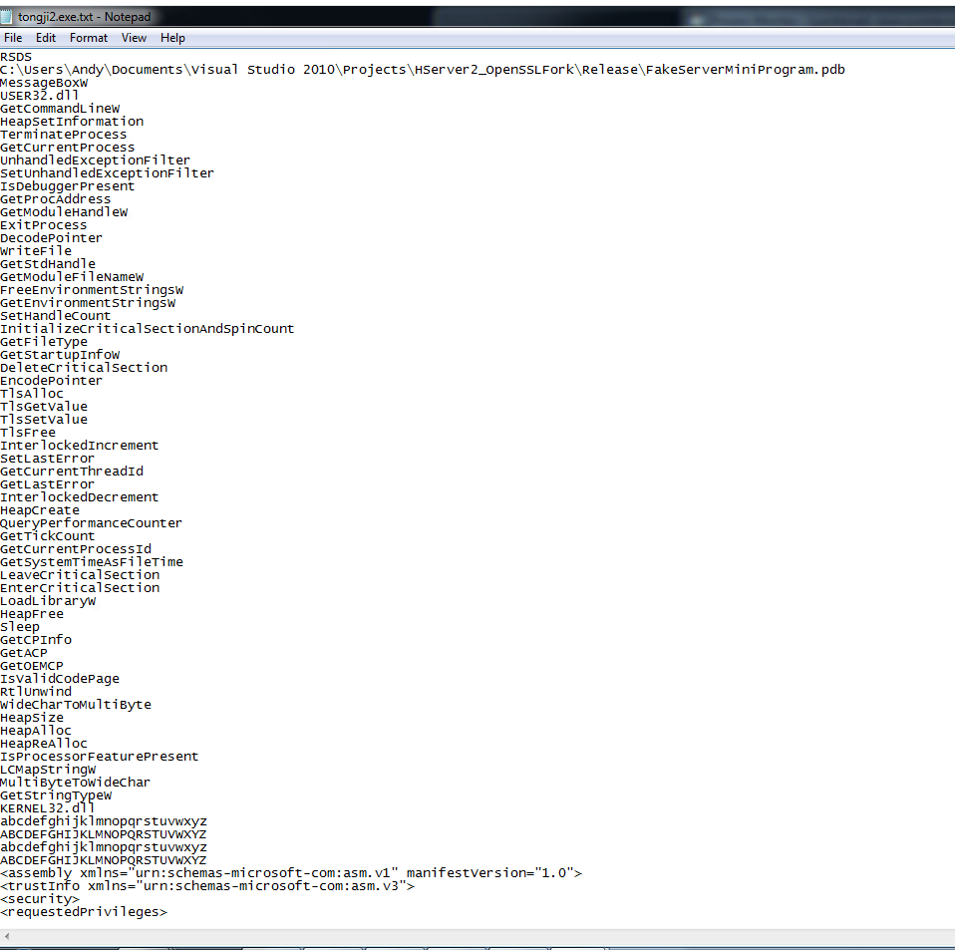
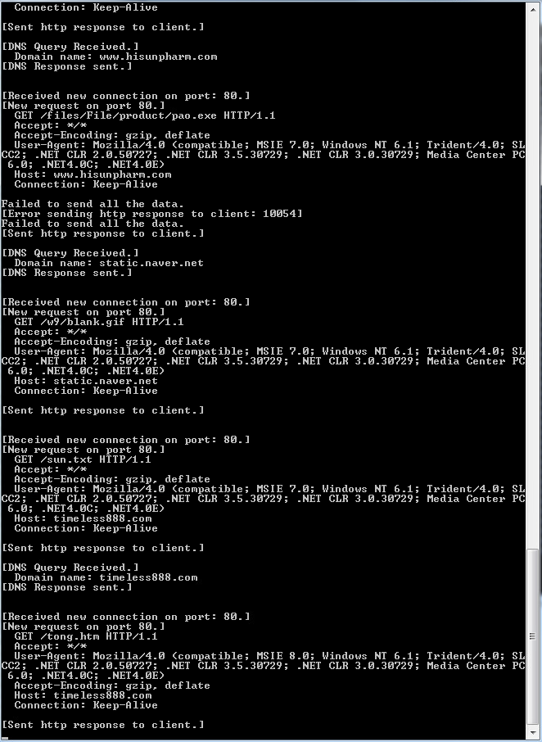
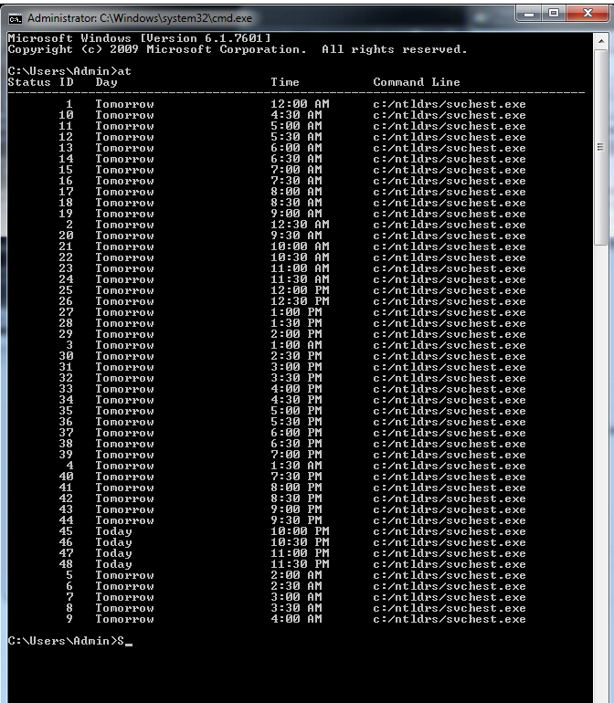
I then had the idea to investigate what happened at one of these 30 minutes intervals/

This evil.exe appears to be collecting system information and sending it out at 30 minutes intervals.

